User Guide

PREREQUISITES

Downloading

1. download MongoDB from https://www.mongodb.com/try/download/community

2. download NodeJS from https://nodejs.org/dist/v18.12.1/node-v18.12.1-x64.msi

Installing

1. Install MongoDB using the installer:

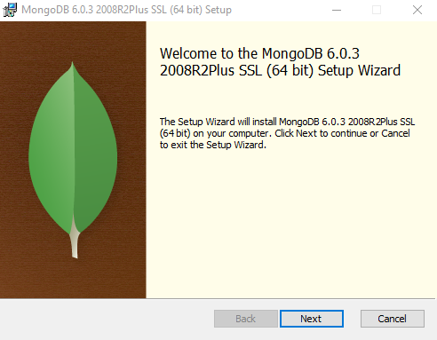

Choose Complete

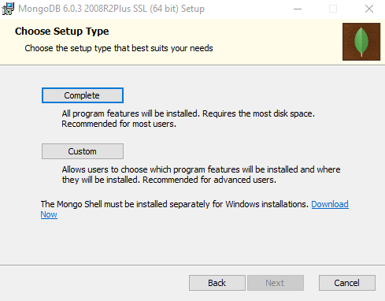

Don’t change anything here, just press next

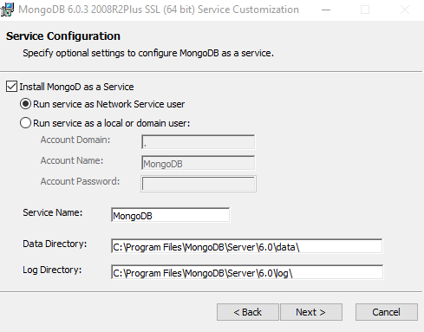

Ensure the “Install MongoDB Compass” is ticked

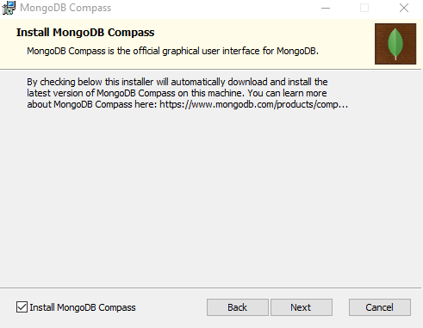

Wait for the install to finish

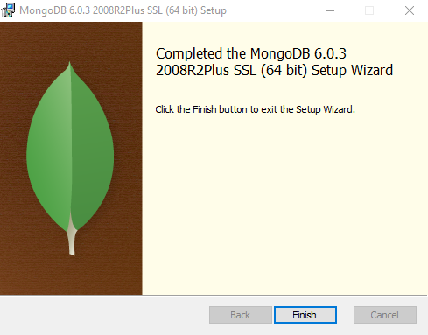

2. Install NodeJs using the installer:

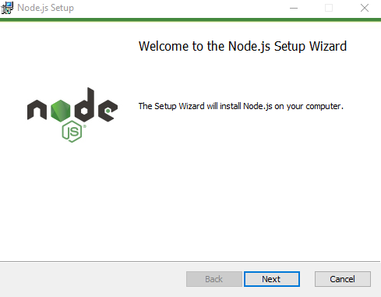

Don’t change anything here, just press next:

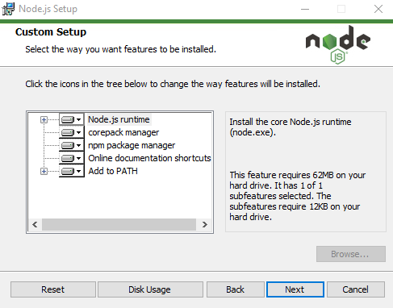

Ensure the “Automatically install the necessary tools” box is un-ticked

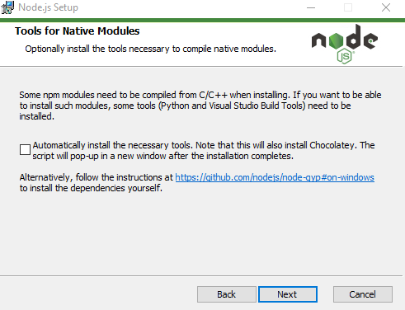

And then wait for the setup to finish

General

1. Check that MongoDB server is installed and running using MongoDBCompass

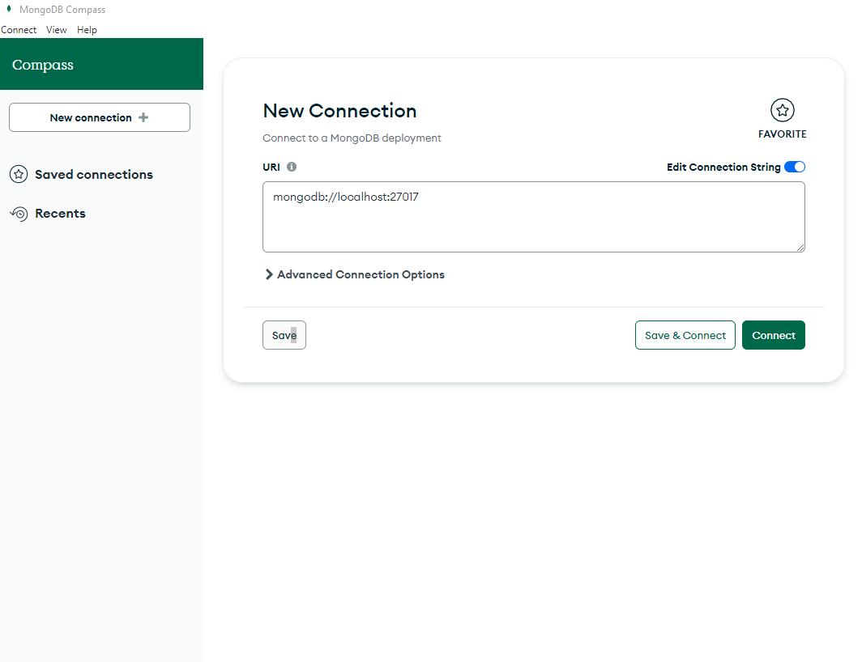

Hit “connect” and then you should see this in the top left corner

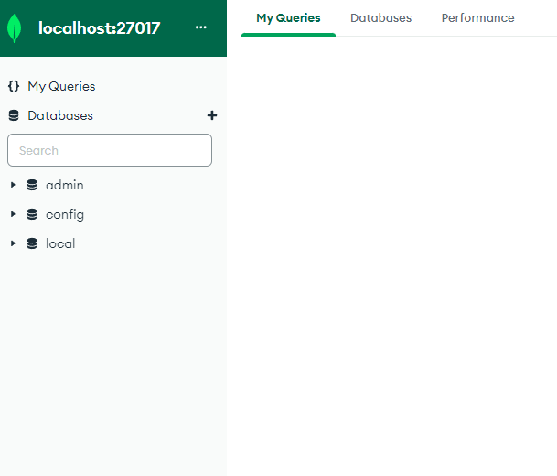

2. Create a new database with MongoDBCompass called "holiday-chat-agent" with a collection called "holidays"

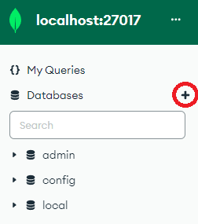

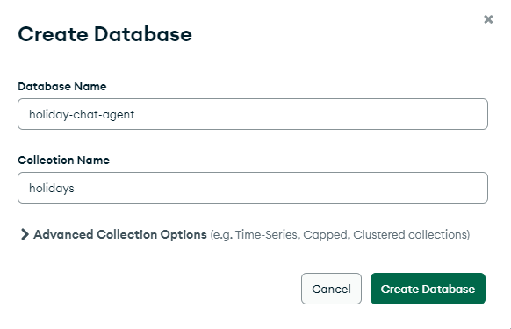

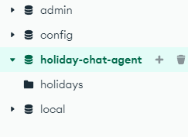

3.In the holidays collection, import the holidays.csv file containing all the holiday data

(Ensure file type is CSV, ignore the rest of the options)

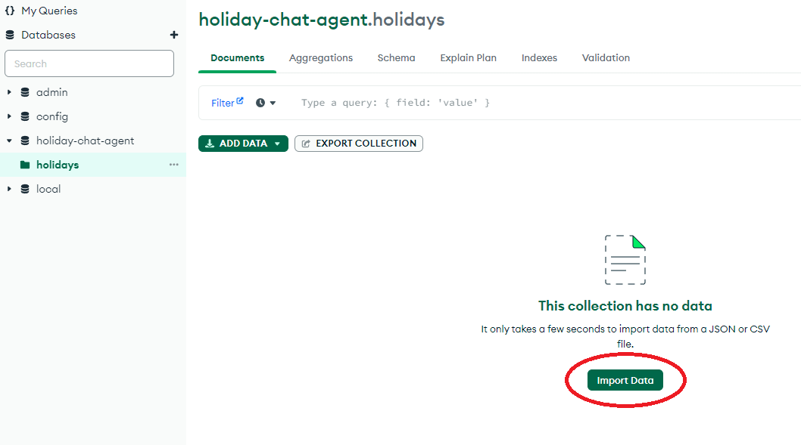

Ensure that HolidayReference, HotelName and PricePerNight are all “Number” rather than “String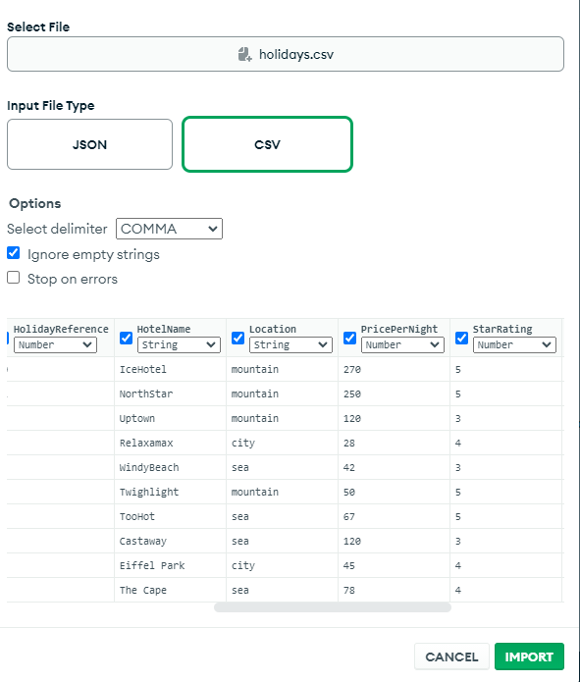

4. Check that NodeJS is installed by opening command prompt and entering "node -v"

START THE APP

1. Open a command prompt and navigate (cd) to the HolidayChatAgent/backend folder

2. Use the "npm i" command to install all node dependencies

3. Use the "nodemon" command to start the server

Upon server start cmd should print:

**[nodemon] starting `node index.js`**

**Server is listening on port: 3000**

**Connected to the Database successfully**

4. Open another command prompt and navigate (cd) to the HolidayChatAgent/frontend folder

5. Use the "npm i" command to install all node dependencies

6. Use the "npm run serve" command to run the frontend server

7. Open a browser and connect to the frontend with the url of http://localhost:8080/

USER GUIDE

Using the app itself it is quite intuitive, the agent will direct you in which keyword to say to start the questions, after all questions have been successfully answered the agent will thank you for using the service and direct you to a start again button.